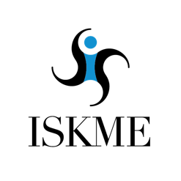
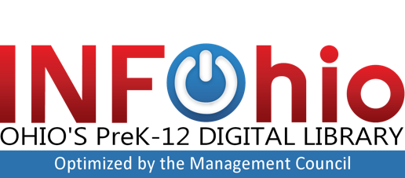
CONTACT INFORMATION
The Management Council
Jessica Madison
614.980.9810
jessica.madison@managementcouncil.org

FOR IMMEDIATE RELEASE

INFOhio Launches Open Space, Ohio’s Premier Platform for
OER Creation
Free to Ohio’s PreK-12 Educators

COLUMBUS, OHIO, February 2019 — INFOhio launched its new open educational resource (OER) platform, Open Space, to empower PreK-12 educators to create and share digital learning tools that promote innovative and collaborative learning. Developed in partnership with the Institute for the Study of Knowledge Management in Education (ISKME), INFOhio’s Open Space creates a free community of creation and collaboration for all of Ohio’s educators.

Geoff Andrews, CEO of the Management Council stated, “Open Space aligns to one of the core principals of the Ohio Department of Education’s new strategic plan – equity. When educators create and share educational content that all Ohio PreK-12 educators can freely use, all students have a level playing field.” Theresa Fredericka, Director of INFOhio concurred, “Open Space provides Ohio’s educators a unique collaboration platform. Now, a teacher in Toledo can work with a teacher in Athens to produce a great science lesson that is easily shared with all Ohio teachers.”

Open Space, licensed and supported by INFOhio, is built on the OER Commons infrastructure. It features all the authoring and collaboration tools found on OER Commons, ISKME's digital library and collaboration platform, while being designed to meet the distinctive needs of Ohio's PreK-12 educators. Open Space curation tools provide a platform to easily access and share Ohio created digital education content and create unique collections focused on Ohio’s education needs.

“Open Space is a place for Ohio educators to work within disciplines and across geographical regions to meet the unique needs of Ohio’s educators and students,” says Lisa A. Petrides, CEO of ISKME that created OER Commons as a digital library of record for open education resources. “Open Space provides an opportunity for Ohio educators to access, curate, evaluate and adapt all kinds of learning materials to meet student needs, interests, and contexts and to deepen learning with tools that are dynamic, relevant, and closely tied to state standards.”

Open Space, built with consultation from the Open Space Advisory Council, is the newest addition to INFOhio's suite of OER tools, which are freely available to Ohio’s PreK-12 students and educators. To learn more about INFOhio and OER, please visit www.infohio.org/oer.

About INFOhio
INFOhio is Ohio’s PreK-12 digital library with a vision that each Ohio PreK-12 student has equal access to high quality digital resources for a successful education and future. INFOhio transforms student learning by licensing a collection of instructional content—selected to support Ohio’s Learning Standards—and making it easily accessible to all Ohio PreK-12 students, their parents, and teachers from any Internet-connected device—at no cost to Ohio's schools. INFOhio is optimized by the Management Council, which represents and supports the collaborative efforts of Ohio’s Information Technology Centers, spanning a vast array of administrative and academic applications that make up the Ohio Education Computer Network. Visit INFOhio at www.infohio.org.

About ISKME
ISKME is an independent education nonprofit with the mission to improve the practice of continuous learning, collaboration, and change in education. Established in 2002, ISKME supports innovative teaching and learning practices globally and is well known for its open education initiatives. ISKME launched the public digital library and collaboration platform, OER Commons, in 2007. In 2018 ISKME and the U.S. Department of Education’s announced a partnership to support the #GoOpen Initiative goal of ramping up the use of open educational resources.

###

